**Installation Guide For Mavericks Step By Step**

Regards : Imran Khan

Installing Mac OS X on PC is not easy as installing windows or linux, because mac os x are made only to be installed on genuine Apple Computers known as Macintosh

Hacking the OS X to be installed on Normal PC is known as **[Hackintosh](http://www.givemesome.tips/about/hackintosh/what-is-hackintosh-for-beginners-and-noobs-151/" \o "Hackintosh" \t "_blank)**,  
This article will show you how to make your **[hackintosh](http://www.givemesome.tips/about/hackintosh/what-is-hackintosh-for-beginners-and-noobs-151/" \o "hackintosh" \t "_blank)** with Niresh’s Mavericks known as 10.9

Making a Perfect **[hackintosh](http://www.givemesome.tips/about/hackintosh/what-is-hackintosh-for-beginners-and-noobs-151/" \o "hackintosh" \t "_blank)** needs special hardware requirements any how with Niresh’s Mavericks you can make it work on most machines without much trouble

**Requirements to create a Bootable USB image:**

An Existing Computer (Windows or Mac)

[Niresh’s 10.9 Distro](http://www.hackintosh.zone/downloads/download/75-nireshs-mavericks-109-with-amd-intel-usb/)

An Empty USB Pen drive with 8GB or more storage

[Win32DiskImager](http://www.hackintosh.zone/downloads/download/75-nireshs-mavericks-109-with-amd-intel-usb/) or [USBIT](http://www.hackintosh.zone/downloads/download/75-nireshs-mavericks-109-with-amd-intel-usb/)  
(You can also use the ISO Version but i needs a blank 8.1 GB DVD)

**With Mac:**

Download “[**Mavericks-Restore Package for Mac**](http://www.hackintosh.zone/downloads/download/75-nireshs-mavericks-109-with-amd-intel-usb/)” extract it,  
place “Niresh’s Mavericks DMG” and “Mavericks Restore Package” in same directory  
plugin your Pen Drive  
Open “Mavericks Restore Package” click continue and select “Change Install Location”

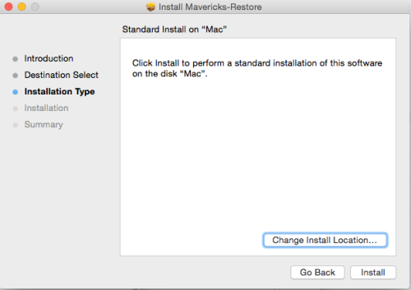  
then select your Pen drive volume name from the list (be careful when selecting the name selecting any other volume name may cause heavy data loss)

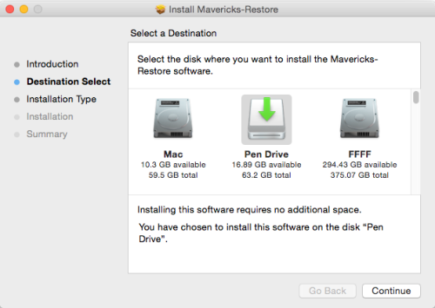  
Press continue and wait for the process to finish

### with Windows:

In windows you can use Win32DiskImager or USBIT to make Mavericks Installation USB

Format your Pen Drive  
Open Win32DiskImager  
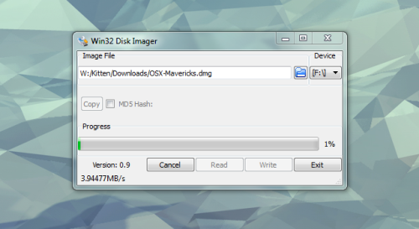  
Select OSX-Mavericks.dmg by clicking the blue icon  
Select your Pen drive from the list Next to the blue icon  
After that click Write and wait for the process to finish

### Setup BIOS:

Setting up BIOS is very important to use hackintosh  
In Bios Menu:  
If HPET is available change it to ON & set HPET Mode as 64 Bit  
Set SATA as AHCI (you may need to revert this to boot into windows again)  
Enable ‘Executive Disable Bit’ (also known as XD Technology) (Disabling this may cause Hackintosh to reboot instantly)  
Enable ‘Virtualization Technology’ (also known as VT Technology)  
USB Legacy to ON (If you experience some usb related issues in verbose mode try switching to OFF)  
If UEFI available turn it off & Enable legacy boot  
Save BIOS settings and restart

### Boot From the USB that you Made

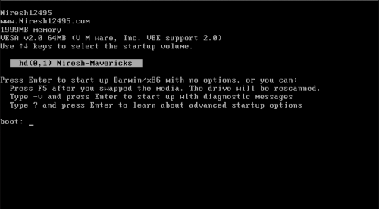

the boot menu will look much similar to the above image  
if you didn’t manage to reach the boot menu check your BIOS settings

#### Niresh Mavericks Bootflags

In this menu you can use multiple boot flags to boot into Niresh’s Mavericks Installer  
this is mostly needed in case if your processor needs a custom kernel or if you face some rare errors to troubleshoot its better to boot with -v (verbose) boot flag  
to use a boot flag simply start typing it & you will be able to see the bootflag on screen  
but in case if you want to use multiple bootflags you can separate it with a space  
Example:

**-v -s**

In the above boot flag verbose mode and safe mode boot flags are combined  
a custom kernel may be needed in order to boot Mavericks in AMD Machines and some intel machines  
AMD Processor:

**amd or amd64**

AMD Buildozer Processors:

**amdfx**

Haswell Processor:

**xpcm-free**

HP Laptops with Haswell Processor:

**xpcm-free cpus=1 -v**

HP Laptops:

**hp**

IVY Bridge Processors:

**ivybridge**

Most laptop users may have to boot with

**-x**

boot flag

AMD users must use chameleon as the Bootloader do not use Clover as boot loader in the Installation  
Fixing boot problems  
this section is only for the users who may face errors during the boot  
Sometimes if the USB flash light stop after a few seconds you may have to use one of the following boot flags

USBBusFix=Yes Enable the EHCI and UHCI fixes (disabled by default).  
EHCIacquire=Yes Enable the EHCI fix (disabled by default).  
UHCIreset=Yes Enable the UHCI fix (disabled by default).  
USBLegacyOff=Yes Force USB Legacy off (disabled by default).

Sometimes booting with -x (safe mode may fix graphics glitching issues)

If it stops in a line where is says PCI Configuration Begins  
try either one of the following boot-flags

**npci=0x3000**

**npci=0x2000**

Gigabyte MotherBoard users should use PCIRootUID=1 & it may solve “PCI Configuration Begins” in some cases

#### Configuring the Installation

When you get into the Installer open “DiskUtility”

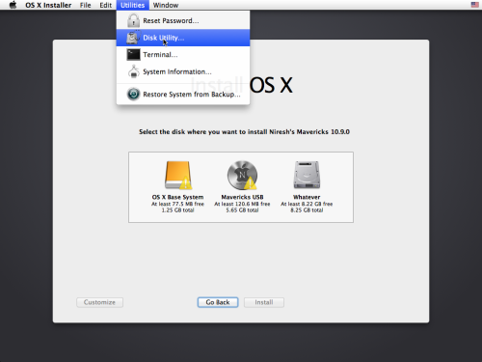

Erase a Hard disk partition as “Mac OS Extended (Journaled)” format, you can set it using Disk Utility’s Partition tab.

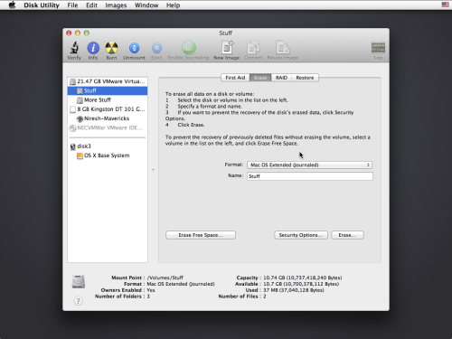

#### Customization:

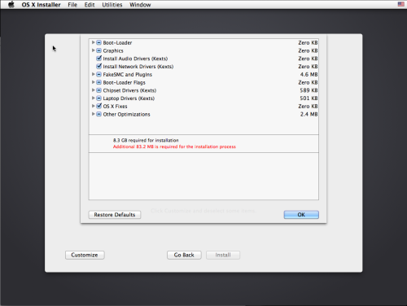

Mostly customization is not needed & most audio and network kexts will be installed automatically by the Installer  
If you have used any special boot-flags to boot into the Installer you have to select the correct package for it  
Example if you have to boot with npci=0x2000 there is a package in the Installer you must select it

after customizing press ok and Select the erased volume and start Installing in that volume

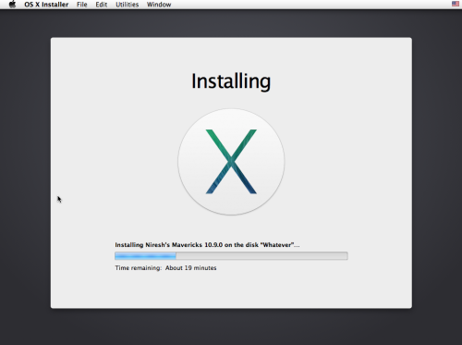

If you face any errors during the installation please include the Installer log and create a post in the forum

After the Installation boot into Mac OS X  
After the Installation There are chances you may run into a few issues  
Black / Grey Screen, Monitor Turn Off Issues & Missing Bluetooth Controller Transport  
To fix reinstall with all the Backup Graphics Extensions Packages Selected or take a look at [**Fix Grey/Black/White Screen Hackintosh**](http://www.givemesome.tips/about/hackintosh/how-to-fix-hackintosh-grey-screen-black-screen-white-screen-no-signal-problem-after-mac-os-x-hackintosh-installation-265/)  
[**FakeSMC: [Fatal] failed to initialize SMC device Error**](http://www.givemesome.tips/about/hackintosh/fix-fakesmc-fatal-failed-to-initialize-smc-device-error-271/)  
[**DSMOS has arrived / waiting for DSMOS**](http://www.hackintosh.zone/hackintosh/articles/fix-dsmos-has-arrived-and-waiting-for-dsmos-problem-hackintosh/)  
[**Still waiting for root device**](http://www.hackintosh.zone/hackintosh/articles/fix-osx-hackintosh-still-waiting-for-root-device/)

PS/2 Keyboard Mouse Not Working  
Boot with Kernel Flag -f

In some rare cases you may loop in account creation menu or you may be brought to a screen which asks for a username and password  
simply enter the following as username and password  
Username: root  
Password: niresh

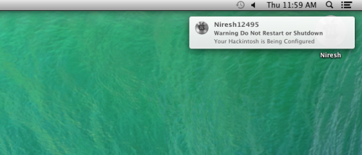The Hackintosh may need some time to configure and rebuild the caches.